

|  |  |  |  |  |  |  |  |  |
| --- | --- | --- | --- | --- | --- | --- | --- | --- |
|  | | | | | | | | |
|  | | Capstone Project – University Ranking | | | | |  | |
|  |  | | | | | | |  |
|  | | | |  |  | | | |
|  | | | | Shiraj Ali Ahmad |  | | | |
|  | | | | —Data Analytics—Shiraj Ali Ahmad |  | | | |
|  | | |  | | |  | | |



|  |  |  |  |  |  |  |  |  |
| --- | --- | --- | --- | --- | --- | --- | --- | --- |
|  |  | | |  |  | | |  |
|  | Overview | | | | | | |  |
|  |  | | |  |  | | |  |
|  |  | |  | | |  | |  |
|  |  |  | The dataset encompasses a wealth of information concerning universities spanning multiple countries, meticulously evaluated across three distinct ranking systems. Additionally, it comprises comprehensive details about the countries housing these esteemed universities, encompassing their representation, specific ranking, as well as intricate criteria employed for assessment. | | |  |  |  |
|  | | | | |
|  |  |  |  |
|  |  |



|  |  |  |  |  |  |  |
| --- | --- | --- | --- | --- | --- | --- |
|  | |  |  |  |  | |
|  | | THE PROCESS | | |  | |
|  | |  |  |  |  | |
|  | 1. Data Acquisition from GitHub:  Obtain the requisite dataset from a designated GitHub repository, containing essential information on university rankings, encompassing various countries and their performance across distinct ranking systems.  2. Data Transformation and Enhancement:  If necessary, execute data transformation procedures to ensure data quality and consistency. Additionally, consider augmenting the dataset with new problem statements to enrich the analysis potential.  3. Connecting with Tools:  Establish connections between the dataset and various analytical tools. Interface the dataset with Power BI, Excel, and MySQL Workbench, facilitating seamless data integration and processing.  4. Problem Statement Solution in Power BI:  Utilize Power BI to delve into the specified problem statements. Employ its robust features for data visualization, exploration, and analysis, effectively deriving insights and solutions.  5. Exploratory Data Analysis (EDA):  Perform exploratory data analysis using either Excel or SQL Workbench, depending on the complexity of the analysis. Extract meaningful patterns, relationships, and trends from the data to inform subsequent decision-making.  6. Creation of Visual and Insightful PowerPoint:    Develop a comprehensive PowerPoint presentation that encapsulates the project's objectives, methodologies, problem statement solutions, and key visualizations. Each problem statement should be accompanied by a dedicated section with pertinent conclusions and insights.  7. Detailed Documentation:  Compile a detailed report that meticulously documents the entire project lifecycle. Include sections on data collection, transformation, problem statement formulation, tools integration, Power BI solutions, EDA insights, and PowerPoint visualizations. | | | | |  |

**Objective**

University rankings are a popular way to compare the quality of different institutions of higher education. However, there are a number of problems with these rankings, including variations across systems, key factors influencing rankings, historical trends, and the impact of limitations and biases on rankings.

The objective of this project is to conduct an exhaustive analysis of the university rankings dataset in order to explore patterns, trends, and factors influencing university rankings across different ranking systems. The goal is to provide insights that can be used to enhance the quality and competitiveness of higher education institutions worldwide.

The project will involve the following tasks:

* Performing a comprehensive analysis of university rankings, including variations across systems, key factors influencing rankings, historical trends, and the impact of limitations and biases on rankings.
* Deriving meaningful conclusions and recommendations for improving ranking methodologies.
* Compiling analysis results, conclusions, and recommendations for stakeholders.

The success of the project will be measured by the following metrics:

* The quality of the analysis
* The relevance of the insights
* The impact of the recommendations

This project is significant because it has the potential to improve the quality and competitiveness of higher education institutions worldwide. By understanding the factors that influence university rankings, institutions can better position themselves to succeed in the global marketplace.

**Significance**

University rankings analysis plays a significant role in the higher education landscape, providing valuable insights for prospective students, researchers, and academic institutions. By delving into the factors that influence university rankings, individuals and institutions can make more informed decisions about where to study or work. Let's explore the significance of university rankings analysis in more detail.

For prospective students, university rankings analysis serves as a valuable resource for making informed decisions about their educational journey. By understanding the criteria used to rank universities, students can assess which institutions align with their academic goals, career aspirations, and personal preferences. They can consider factors such as reputation, faculty expertise, research opportunities, student satisfaction, and employment prospects. This information empowers students to choose universities that best suit their needs, increasing the likelihood of a fulfilling and successful educational experience.

Similarly, researchers can benefit from university rankings analysis when deciding where to pursue their academic careers. By examining the rankings, researchers can identify institutions that excel in their specific fields of interest. This knowledge allows them to align themselves with universities that have strong research programs, funding opportunities, and collaborative networks. Such strategic decision-making can enhance their research output, visibility, and career progression.

Academic institutions themselves can leverage university rankings analysis to identify areas for improvement. By understanding the criteria that ranking organizations prioritize, institutions can focus their efforts on enhancing those specific aspects. For example, if a ranking heavily emphasizes research output, an institution can invest in research infrastructure, faculty recruitment, and collaboration initiatives to bolster its ranking position. This data-driven approach enables institutions to allocate resources effectively and strategically, ultimately enhancing their overall academic standing.

Moreover, university rankings analysis is crucial for policymakers in assessing the effectiveness of ranking systems. By comprehending how rankings are calculated, policymakers can ensure that the methodologies are fair, transparent, and accurately reflect the quality of institutions. They can identify any biases or limitations in the ranking systems and work towards improving their accuracy and reliability. Policymakers can also use historical analysis of university rankings to identify trends, benchmark performance, and develop strategic plans for the advancement of higher education.

Furthermore, university rankings analysis facilitates comparisons between institutions, enabling data-driven decisions for improving higher education quality and competitiveness. By examining the rankings of different institutions, universities can identify best practices and successful strategies that can be adopted to enhance their own performance. This fosters a culture of continuous improvement and encourages institutions to strive for excellence in various areas, such as teaching quality, student support services, internationalization efforts, and community engagement.

In conclusion, university rankings analysis provides valuable insights for prospective students, researchers, academic institutions, and policymakers. It enables individuals to make informed decisions about their educational and career paths, helps institutions identify areas for improvement, allows policymakers to assess ranking system effectiveness, and promotes data-driven decision-making for enhancing higher education quality and competitiveness. By embracing the insights gained from university rankings analysis, stakeholders in the higher education sector can work collaboratively towards creating a more robust and impactful academic environment.

**Data Dictionary:**

Table: Country

- Fields:

- country_id: Unique identifier for each country.

- country_name: Name of the country.

Table: University

- Fields:

- university_id: Unique identifier for each university.

- university_name: Name of the university.

- country_id: Foreign key referencing the country_id field in the Country table.

Table: Ranking system

- Fields:

- ranking_system_id: Unique identifier for each ranking system.

- ranking_system_name: Name of the ranking system.

Table: Ranking criteria

- Fields:

- ranking_criteria_id: Unique identifier for each ranking criteria.

- ranking_criteria_name: Name of the ranking criteria.

- ranking_system_id: Foreign key referencing the ranking_system_id field in the Ranking system table.

Table: University_year

- Fields:

- university_year_id: Unique identifier for each university year.

- university_id: Foreign key referencing the university_id field in the University table.

- number_of_students: Number of students in the university for a specific year.

- female_population: Population of female students in the university for a specific year.

- international_population: Population of international students in the university for a specific year.

- student_to_staff_ratio: Ratio of students to staff members in the university for a specific year.

Table: University_ranking_year

- Fields:

- university_ranking_year_id: Unique identifier for each university ranking year.

- ranking_criteria_id: Foreign key referencing the ranking_criteria_id field in the Ranking criteria table.

- university_id: Foreign key referencing the university_id field in the University table.

- score: Score of the university for a specific ranking criteria and year.

- year: Year of scoring for the university.

The data dictionary provides a comprehensive overview of the tables and their respective fields in the dataset. It outlines the relationships between the tables, allowing for a better understanding of the data structure and facilitating the design and implementation of the Power BI Dashboard.

**ER Diagram**

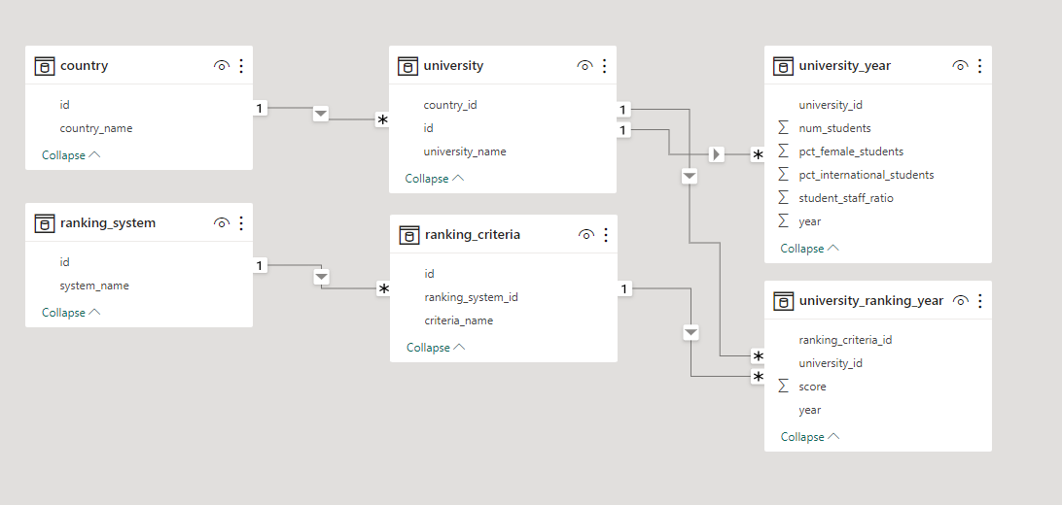

**Power BI Problem Statements**

**[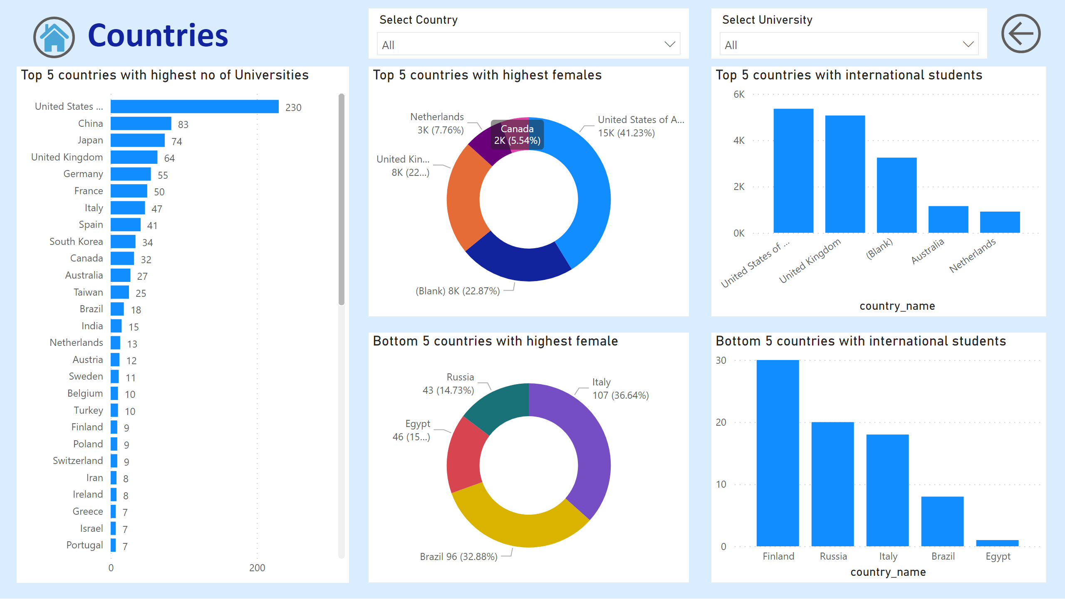](https://app.powerbi.com/groups/me/reports/f055a63d-eada-463a-802a-2957e30805e8/?pbi_source=PowerPoint)**

How many universities are there in each country?

Analyzing the number of universities in each country offers valuable insights into the global higher education landscape. By examining the data from the Country Report, we can identify the nations with the highest and lowest counts of universities. Countries like the United States, China, and Japan have a significant number of universities, reflecting their strong investment in education and research. On the other hand, countries such as Uganda, the UAE, and Uruguay have a comparatively lower count of universities, which could be influenced by factors such as population size, economic development, and educational policies. This analysis provides policymakers, researchers, and educators with a deeper understanding of the distribution of educational institutions worldwide, guiding future decisions in educational planning, resource allocation, and international collaborations.

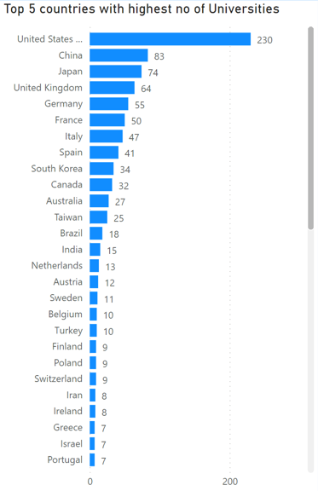

Which country has the highest number of female students enrolled in universities?

Investigating the enrollment of female students across different countries sheds light on gender diversity and educational access. The data reveals leading countries like the United States, the United Kingdom, and the Netherlands that prioritize gender equality and offer inclusive educational opportunities. Conversely, lagging countries such as Italy, Brazil, and Egypt might indicate existing gender disparities or barriers in these societies. Enhancing data accuracy and availability is crucial to further explore the challenges faced by female students in education. Policymakers can utilize these insights to formulate strategies that promote equitable access to education and empower women to pursue higher studies, ultimately contributing to socioeconomic development and inclusive growth.

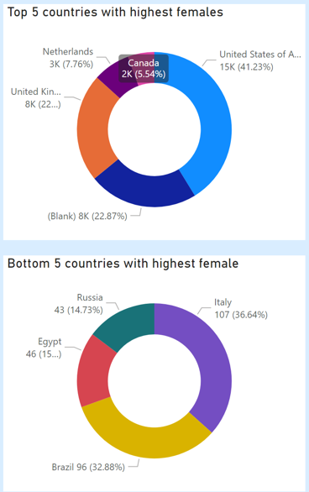

What is the distribution of international students across different countries?

Analyzing the distribution of international students across countries provides insights into global educational mobility trends. Countries like the United States, the United Kingdom, Australia, and the Netherlands are popular destinations for international students due to their diverse academic offerings and welcoming environments. In contrast, Finland, Russia, and Italy attract fewer international students, possibly due to language barriers or limited program offerings. This analysis helps educational institutions understand their global appeal and tailor strategies to attract and retain international students. By enhancing data collection and sharing, universities can collaborate to improve their internationalization efforts, foster cultural exchange, and create a vibrant global learning community.

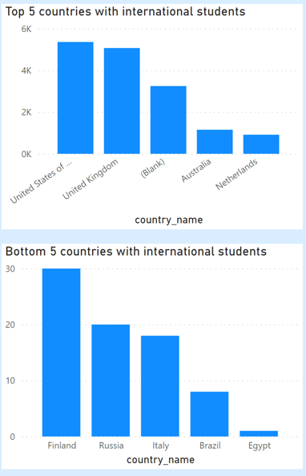

Is there a correlation between a university's ranking and its student-staff ratio?

Exploring the correlation between a university's ranking and its student-staff ratio unveils insights into institutional performance metrics. While the data may not immediately reveal a direct correlation, a deeper analysis can illuminate factors influencing this relationship. Universities with lower student-staff ratios might prioritize personalized education and individual attention, impacting student satisfaction and potentially leading to improved rankings over time. Conversely, institutions emphasizing research output or specialized programs may have higher student-staff ratios without adversely affecting their rankings. By comprehensively examining this correlation, institutions can optimize resource allocation, improve teaching quality, and enhance student experiences, all of which contribute to improved institutional rankings.

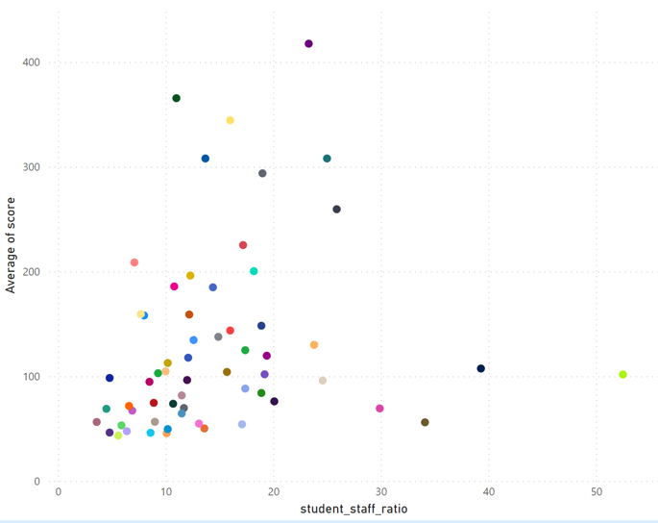

What is the correlation between the average score and the student-staff ratio for universities?

Investigating the correlation between a university's average score and its student-staff ratio provides insights into academic performance and resource allocation. The analysis reveals that many universities exhibit an average score below 200 coupled with a student-staff ratio around 20. While this correlation may suggest that institutions with moderate student-staff ratios achieve lower average scores, it's important to consider various factors influencing academic performance. Institutions with higher scores might prioritize research output, faculty quality, or specialized programs that contribute to a higher student-staff ratio. Institutions can use this analysis to make informed decisions about resource allocation, faculty recruitment, and student support services to maintain a balanced approach to academic excellence.

Which university has the highest number of students?

Utilizing a card visualization, it becomes evident that Arizona State University has the highest student enrollment among all universities. This information highlights the institution's capacity to cater to diverse educational needs and foster a robust academic community. Arizona State University's ability to accommodate a substantial number of students underscores its comprehensive program offerings, modern facilities, and effective administrative strategies. The insight gained from this visualization assists institutions in benchmarking their enrollment figures, understanding the strategies enabling successful management of student populations, and developing approaches that promote student success and academic growth.



How does the percentage of international students vary across different universities?

The creation of a table showcasing the percentage of international students for each university allows for a comprehensive examination of global educational diversity. By using slicers and interactive visuals, stakeholders can analyze how the percentage of international students fluctuates across diverse institutions. This analysis is pivotal for understanding patterns and trends in international student enrollment. Universities with higher percentages of international students often possess a global appeal, academic reputation, and efforts to create an inclusive learning environment. Universities with lower percentages might have different strategic priorities or face barriers that impact their international student recruitment efforts. By analyzing these patterns, institutions can refine their internationalization strategies, foster diversity and cross-cultural exchange, and enrich the educational experience for all students.

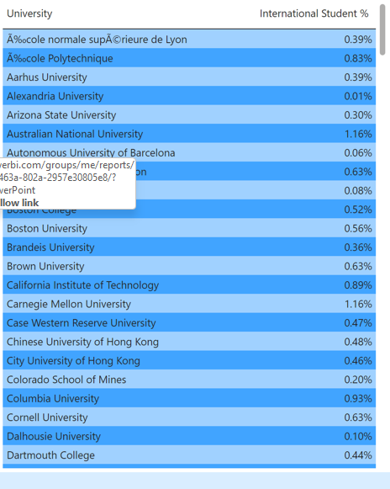

How many universities are ranked by each ranking system?

The pie chart offers a visual representation of the distribution of universities among different ranking systems. This visual insight highlights the influence and recognition specific ranking systems hold within the higher education community. The prevalence of universities under certain ranking systems reflects diverse perspectives and evaluation criteria. While each system may have unique methodologies, this visualization emphasizes the importance of understanding and engaging with a variety of ranking approaches. Stakeholders can use this information to navigate the complex landscape of university rankings, tailor their engagement with different systems, and develop strategies to improve institutional visibility and reputation across multiple platforms.

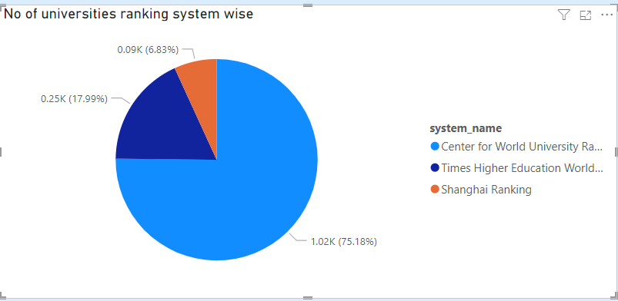

What is the average score for each ranking system?

Visual representation of the average scores for different ranking systems furnishes a comprehensive overview of how universities perform under varying criteria. This insight enables institutions to assess their strengths and weaknesses relative to each ranking system's evaluation metrics. Higher average scores suggest alignment with specific criteria such as research output, faculty quality, or internationalization efforts. Conversely, lower average scores might indicate areas for improvement. Institutions can use this analysis to strategically invest resources, enhance academic programs, and bolster performance in areas that influence rankings. By understanding the nuances of each ranking system's assessment, institutions can tailor their strategies to elevate their standing and enhance their global reputation.

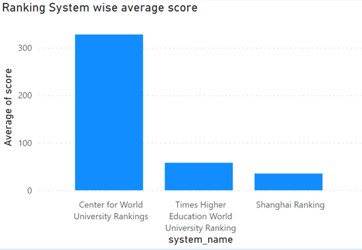

What is the correlation between the average score and the student-staff ratio for universities for each ranking system?

By dissecting the correlation between a university's average score and its student-staff ratio across different ranking systems, a more nuanced understanding of institutional dynamics comes to light. Exploring this correlation within each ranking system allows institutions to identify specific performance trends that impact their standing. Institutions with higher student-staff ratios might excel in certain criteria, such as research output, while those with lower ratios could prioritize teaching quality and student support. This analysis helps institutions align their strategies with the unique evaluation criteria of each ranking system, fostering a holistic approach to improving their global reputation and academic performance.

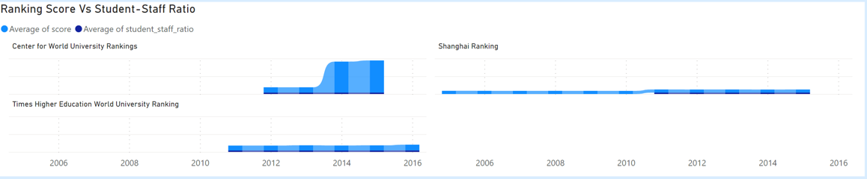

How does the percentage of female students impact a university's ranking?

The intricate relationship between the percentage of female students and a university's ranking unfolds through visual analysis. This examination provides valuable insights into gender diversity within higher education institutions and its potential influence on institutional reputation. Universities with higher percentages of female students might prioritize gender equality, inclusive policies, and diverse academic offerings. This commitment to diversity and gender equity could enhance a university's overall appeal and contribute to a more positive reputation. By leveraging this analysis, institutions can refine their recruitment strategies, create supportive environments for female students, and communicate their commitment to inclusivity, ultimately enhancing their global standing and contributing to societal progress.

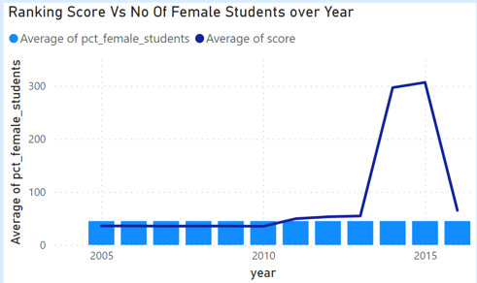

What are the most important criteria considered by ranking systems?

A meticulous analysis of the visual representation underscores the paramount significance of specific criteria in shaping a university's ranking. Alumni Employment, Citations Rank, and Influence Rank emerge as pivotal factors influencing institutional performance. Institutions excelling in these criteria tend to have a strong focus on graduate outcomes, research impact, and societal contributions. This insight empowers universities to prioritize strategic initiatives that align with these critical criteria. By enhancing career services, fostering research collaborations, and engaging with the broader community, institutions can improve their global reputation, attract top talent, and contribute meaningfully to advancements in knowledge and society.

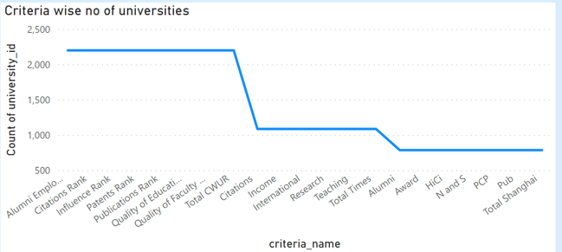

Is there a correlation between a university's score and the number of international students?

Through a comprehensive visual analysis, the potential correlation between a university's average score and the number of international students becomes apparent. This insight unveils a potential interplay between academic excellence and the institution's global appeal. A positive correlation could signify that universities excelling academically also tend to attract a higher number of international students seeking quality education and research opportunities. Such institutions might possess resources, reputation, and programs that attract a diverse and talented student body. Conversely, a negative correlation could suggest that certain universities prioritize internationalization efforts independently of their academic performance. These institutions might actively recruit international students as part of their strategic goals, irrespective of their overall average scores. Understanding this correlation enables institutions to make informed decisions about internationalization strategies that complement their academic mission and enhance their global standing.

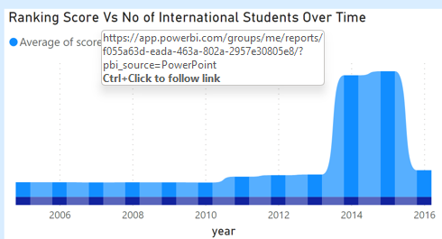

What is the average score for each criterion of the ranking system?

The visual representation provides a nuanced understanding of the average scores for different criteria within the ranking system. Interestingly, Publications Ranking emerges with the highest average ranking among all criteria, underscoring its significance in evaluating institutional excellence. Publications Ranking speaks to the university's research output, visibility, and impact within the academic community. This criterion's prominence signifies the crucial role research plays in influencing an institution's reputation and global standing. This insight guides institutions in allocating resources, fostering research collaborations, and promoting a culture of scholarly productivity. By excelling in this criterion, universities can enhance their academic reputation, attract top-tier faculty, and contribute meaningfully to advancements in knowledge.

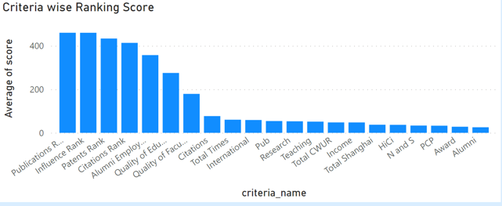

Is there a correlation between a university's ranking score and the student-staff ratio over the years?

The dual-axis visual representation thoughtfully captures the relationship between a university's average score and its average number of international students, along with the average student-staff ratio over time. This in-depth analysis reveals potential trends and interactions between these vital metrics. Exploring this relationship over time can unveil valuable insights. For instance, an upward trajectory in both average score and international student enrollment could signify a virtuous cycle wherein academic excellence attracts global talent. Conversely, a disproportionate increase in student-staff ratio could impact academic quality and potentially influence the ranking score. By monitoring this correlation, institutions can proactively tailor their strategies, allocate resources, and manage student-staff ratios to maintain a harmonious balance between academic quality and student support.

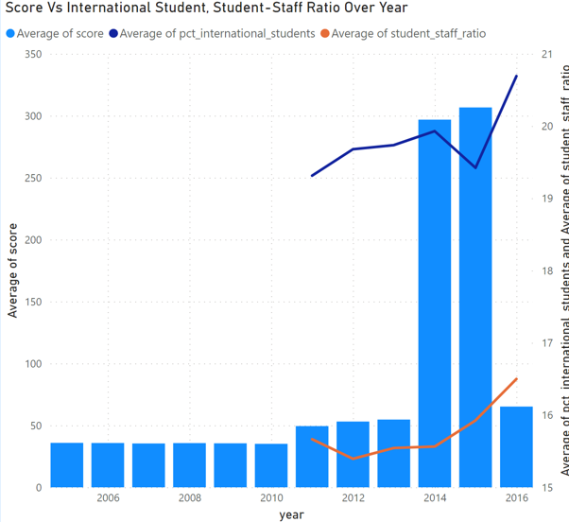

How does the number of students in universities change over time?

A discernible drop in the number of students between the years 2015 and 2016 is evident from the visual representation. This temporal trend could be attributed to various factors, including shifts in enrollment patterns, changes in societal demographics, or alterations in institutional offerings. To unravel the precise reasons behind this decline, a multifaceted approach is necessary. Exploring changes in educational policies, economic conditions, and societal preferences can provide a comprehensive understanding of this trend and guide institutions in adapting to evolving student demands. Understanding fluctuations in student enrollment over time is essential for institutions to make informed decisions, allocate resources effectively, and develop strategies that cater to changing student dynamics.

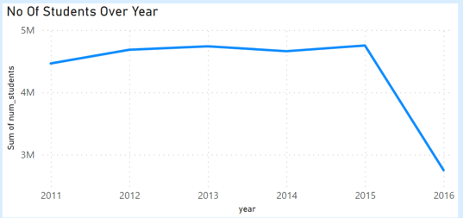

How does the number of international students in universities change over time?

A notable decrease in the number of international students between 2015 and 2016 is apparent from the visual representation. This phenomenon could be indicative of global trends, external factors, or changes in immigration policies that impacted international student mobility during that period. To delve deeper into this decline, a comprehensive analysis is required. Exploring geopolitical influences, economic shifts, and institutional efforts to attract and retain international students can provide a holistic perspective on the dynamics affecting international student enrollment. Understanding these fluctuations over time aids institutions in devising responsive strategies that cater to international students' needs, foster a welcoming environment, and contribute to a vibrant global academic community.

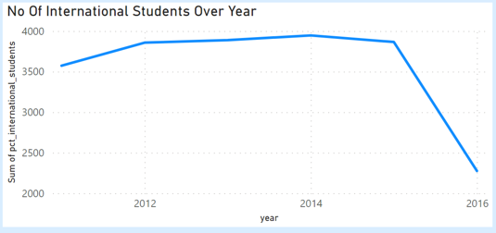

Is there a correlation between a country's GDP and the number of universities?

While the current dataset lacks relevant data to establish a direct correlation between a country's GDP and the number of universities, integrating external open-source data can facilitate the creation of a comprehensive visualization. This visualization can unveil potential connections between economic strength and educational infrastructure. Analyzing this correlation provides valuable insights into how economic resources influence a country's investment in higher education. Nations with higher GDPs might exhibit a propensity to allocate more resources to educational institutions, leading to a greater number of universities. By undertaking this analysis, institutions and policymakers can make informed decisions about educational funding, resource allocation, and strategies for sustainable economic growth.

How has the number of universities changed over the years in each country?

A detailed analysis of the visual representation depicting changes in the number of universities over time for each country provides valuable insights into the evolving higher education landscape. This analysis sheds light on the dynamic shifts that can be attributed to various factors, including changes in educational policies, population growth, and societal priorities. Countries experiencing economic growth might witness an expansion of higher education opportunities, driven by increased investments and demand. Conversely, economic downturns or shifts in educational priorities might lead to stagnation or reductions in university numbers. Understanding these trends over time empowers governments, policymakers, and educational leaders to adapt their strategies, allocate resources effectively, and develop initiatives that align with the evolving needs of their populace.

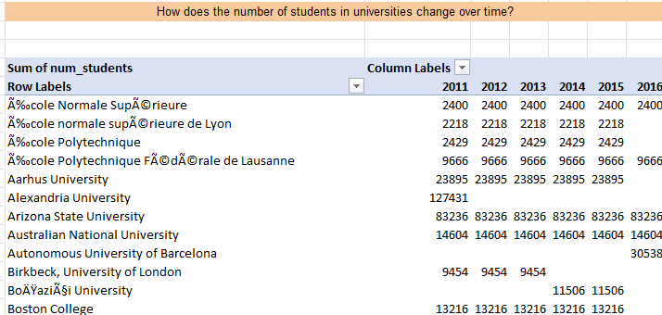

What is the trend in university rankings over the years according to each system?

Visualizing the trend in university rankings over time, categorized by different ranking systems, offers a comprehensive view of the ebb and flow of institutional recognition. This analysis provides insights into the changing dynamics of academic excellence and institutional performance within the context of various ranking methodologies. By examining these trends, institutions can identify periods of ascension or decline, understand the impact of strategic initiatives, and refine their approaches to enhance their standing. Moreover, this analysis enables universities to benchmark their progress against peer institutions and make data-driven decisions that contribute to ongoing academic improvement and global competitiveness.

How does the choice of ranking system affect a university's international student enrollment?

Although a direct correlation between ranking systems and international student enrollment isn't immediately evident, a comprehensive exploration of international student numbers for each university provides valuable insights. Universities with higher international student enrollment might benefit from their global reputation, diverse academic offerings, and inclusive campus environments. However, other factors such as geographic location, language of instruction, and scholarship opportunities also play a crucial role in attracting international students. By delving into the impact of ranking systems on international student enrollment, institutions can enhance their understanding of global student preferences and tailor their internationalization strategies to align with these preferences. This analysis aids institutions in creating a welcoming and supportive environment that resonates with prospective international students and contributes to a vibrant global educational community.

How have the weights of ranking criteria changed over time?

Given the constraints of the available dataset, a comprehensive analysis of the changing weights of ranking criteria over time is challenging. However, recognizing the importance of this inquiry, future efforts could integrate additional data sources to track the evolution of ranking criteria weights. Understanding how criteria weights change over time is essential for institutions aiming to improve their rankings. It enables institutions to align their strategic initiatives, academic programs, and research endeavors with the evolving expectations of ranking systems. By undertaking this analysis, institutions can proactively position themselves to excel in criteria that hold increasing importance, ultimately bolstering their global reputation and influence within the academic community.

Is there a correlation between a university's score and the student-staff ratio?

The existing dataset does not provide a direct relationship between a university's score and the student-staff ratio, rendering a detailed analysis challenging. However, recognizing the potential significance of this correlation, institutions could collaborate to collect more granular data for future insights. Exploring the potential correlation between a university's score and the student-staff ratio holds value for institutions seeking to optimize resource allocation and improve academic quality. A strong correlation could indicate that universities with favorable student-staff ratios tend to excel academically, underscoring the importance of personalized attention and quality teaching. This analysis, once feasible with more comprehensive data, would guide institutions in fine-tuning their strategies to balance academic excellence, student support, and efficient resource utilization.

Is there a correlation between a country's GDP and the number of universities?

While the given dataset lacks direct information to establish a correlation between a country's GDP and the number of universities, the possibility of utilizing external open-source data holds promise for uncovering this relationship. Examining this correlation is essential for understanding the interplay between economic development and higher education infrastructure. Countries with higher GDPs may possess greater financial capacity to invest in education, resulting in a higher number of universities. Conversely, countries with lower GDPs might prioritize other sectors, leading to fewer universities. The integration of comprehensive data can illuminate this correlation, enabling institutions and policymakers to make informed decisions regarding educational funding, resource allocation, and strategies for sustainable economic growth.

How has the number of universities changed over the years in each country?

A detailed analysis of the visual representation depicting changes in the number of universities over time for each country provides valuable insights into the evolving higher education landscape. The temporal variations highlight dynamic shifts influenced by social, economic, and educational factors. These fluctuations can be attributed to a multitude of reasons, including changes in educational policies, population growth, and societal priorities. Nations experiencing economic booms might witness an expansion of higher education opportunities, whereas economic downturns could lead to stagnation or reductions. This analysis is pivotal for governments, policymakers, and educational leaders to adapt to changing educational demands, allocate resources judiciously, and develop strategies that align with the evolving needs of their populace.